 | 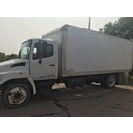 |  |  | 601. 2005 Hino 268 Medium Duty Box Truck
 |  |  |  | Bid on this fabulous Hino box truck with 472,440 miles. The body is a Morgan witgh 24'0" load length, 8'6" width and 12'6" height featuring a roll overhead door. Go check it out at the site of our new Boys and Girls Home and Family Services at the old shopping center in Indian Hills. (Sold as is.)
 |  |  |  |  | Starting Bid: | $1,000 |  | Value: |  | $1,000
 | 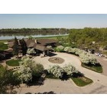 |  |  | 602. Dakota Dunes Country Club 18 rounds for (4) people with cart (KSCJ)
 |  |  |  | Donated by: Dakota Dunes Country Club
 |  |  |  | Enjoy a day at the beautiful Dakota Dunes Golf Course. Designed by golf legend Arnold Palmer, Dakota Dunes Golf Course boasts the newest hybrid of bent grass providing excellent play for all golfers. The 18 hole championship course encompasses 7,165 yards of fairways and greens dotted with lakes and many strategically located bunkers. Dakota Dunes Country Club has been rated the best in the state by both Golf Digest and Golf Week. A diamond in the Midwest.
 |  |  |  |  | Starting Bid: | $450 |  | Value: |  | $540
 | 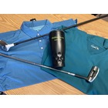 |  |  | 603. Hidden Acres Golf Course Package
 |  |  |  | Donated by: Hidden Acres Golf Course
So much in one small package!
$20 Gift Certificate Hidden Acres
Srixon Q Star Tour sleeve of balls
Wilson Harmonized Putter
Wilson Killer Wale Driver
Hidden Acres Coffee Mug
Arnold Palmer Medium Turf Shirt
Adidas ClimaCool Large Polo
 |  |  |  |  | Starting Bid: | $200 |  | Value: |  | $250
 | 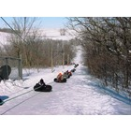 |  |  | 604. Hillview Park Tubing Private Night
 |  |  |  | Donated by: Plymouth County Conservation Office
 |  |  |  | Enjoy a private night for up to 20 people on the Hillview Park Tubing Hill (extra people $5 each). Available Mon thru Fri evenings, reservation required. Good for this season or next!
 |  |  |  |  | Starting Bid: | $75 |  | Value: |  | $100
 | 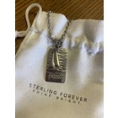 |  |  | 605. Okoboji Sailboat Pendant
 |  |  |  | Donated by: Parks Marina Inc
 |  |  |  | Enjoy this beautiful Okoboji Sailboat Pendant donated by Parks Marina.
 |  |  |  |  | Starting Bid: | $50 |  | Value: |  | $80
 | 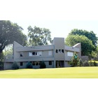 |  |  | 606. 4 18-hole Rounds of Golf at Floyd Park Golf Course
 |  |  |  | The 18-hole Floyd Park course in Sioux City’s Morningside neighborhood provides a great golf option for all golfer levels. The course features 4,067 yards of golf from the longest tees for a par of 63, and features hilly terrein, some water hazards, and mature trees. The course rating is 62.2 and it has a slope rating of 103. Floyd Park golf course opened in 1976. Bob Walker, PGA is the Head Golf Professional.
 |  |  |  |  | Starting Bid: | $45 |  | Value: |  | $68
 | KSCJ
 | 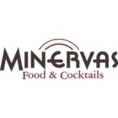 |  |  | 607. $50 Minerva's Gift Card
 |  |  |  | Donated by: Minerva's
 |  |  |  | Enjoy a $50 gift card to this airy, refined restaurant featuring contemporary steak, seafood & pasta dishes.
 |  |  |  |  | Starting Bid: | $35 |  | Value: |  | $50
 | 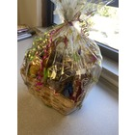 |  |  | 608. Palmer Candy Basket
 |  |  |  | Donated by: Palmer Candy Co
 |  |  |  | Enjoy this fabulous basket filled to the brim with candy from Palmer Candy Co. A Sioux City tradition!
 |  |  |  |  | Starting Bid: | $25 |  | Value: |  | $40
 | 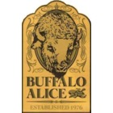 |  |  | 609. $25 Buffalo Alice Gift Card
Buffalo Alice's - Just the right amount of wrong!
Buffalo Alice..or around these parts we call it B.A.'s. One of the best pizzas here in town and a great place to hit up before concerts or to meet up with friends!
 |  |  |  |  | Starting Bid: | $20 |  | Value: |  | $25
 | 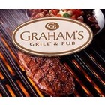 |  |  | 610. $20 Gift Certificate to Graham's Pub (x3)
 |  |  |  | Donated by: Graham's Grill & Pub
 |  |  |  | Graham's Grill & Pub can best be described as a restaurant and sports bar with a casual, yet fun atmosphere. Our goal is to provide you with whatever your taste buds could possibly desire. Our pub recently added six new televisions so you enjoy all the sports you can handle.
 |  |  |  |  | Starting Bid: | $13 |  | Value: |  | $20
 | KSCJ
 | 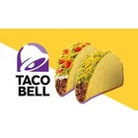 |  |  | 611. Live Mas - $20 Gift Cards for Taco Bell
(4) $5 Gift Cards for Taco Bell.
Taco Bell® has all of your favorite Mexican inspired foods. From classic tacos to burritos to our epic specialties and combos, there’s something for everyone at Taco Bell® .
 |  |  |  |  | Starting Bid: | $15 |  | Value: |  | $20
 | 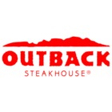 |  |  | 612. $10 Gift Card to Outback + Free Bloomin' onion (X5)
 |  |  |  | Donated by: Outback Steakhouse
 |  |  |  | The home of juicy steaks, spirited drinks and Aussie hospitality. Enjoy steak, chicken, ribs, fresh seafood & our famous Bloomin' Onion. Receiuve a $10 gift card PLUS a certificate for a free bloomin' onion.
 |  |  |  |  | Starting Bid: | $10 |  | Value: |  | $18
 | 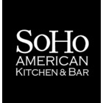 |  |  | 613. $15 Soho Kitchen Gift Card (x5)
 |  |  |  | Donated by: Soho American Kitchen & Bar
 |  |  |  | Enjoy this family-owned haunt with a New York theme, homemade American comfort food & ample craft beers on tap.
 |  |  |  |  | Starting Bid: | $10 |  | Value: |  | $15
 | 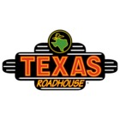 |  |  | 614. Free Entree at Texas Roadhouse (X4)
 |  |  |  | Donated by: Texas Roadhouse
 |  |  |  | Enjoy a free entree (up to $15 value) at this lively chain steakhouse serving American fare with a Southwestern spin amid Texas-themed decor.
 |  |  |  |  | Starting Bid: | $10 |  | Value: |  | $15
 | KSCJ
 | 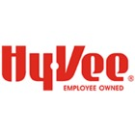 |  |  | 701. HyVee Delivery for a Year ($100 Gift Card)
 |  |  |  | Donated by: HyVee
 |  |  |  | HyVee has donated a $100 gift card which can be used for groceries OR for their excellent delivery for a year from HyVee Aisles Online. Enjoy all the HyVee has to offer either in the store or from the comfort of your home.
 |  |  |  |  | Starting Bid: | $80 |  | Value: |  | $100
 |  |  |  | 702. Popcorn for a Year! (X2)
 |  |  |  | Donated by: American Pop Corn Co.
 |  |  |  | Enjoy a box of popcorn every month for a year. Included are 12 coupons for 3 or 4 count packs of Jolly Time Popcorn!
 |  |  |  |  | Starting Bid: | $45 |  | Value: |  | $60
 | 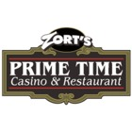 |  |  | 703. $50 Zort's Prime Time
Enjoy some of the best prime rib in the area!
Zort's Prime Time is a locally owned Casino, Restaurant and Bar in North Sioux City. Featuring Zort’s Famous CAB Prime Rib and Smoking Hot Slots!
 |  |  |  |  | Starting Bid: | $35 |  | Value: |  | $50
 | 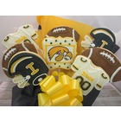 |  |  | 704. Sugar Shack Iowa cookie bouquet
 |  |  |  | Donated by: The Sugar Shack
 |  |  |  | Enjoy this custom made cookie bouquet from Siouxland's own Sugar Shack. Perfect for the Hawkeye Fan in your life!
 |  |  |  |  | Starting Bid: | $40 |  | Value: |  | $50
 | KSCJ
 |  |  |  | 705. Sugar Shack Iowa State cookie bouquet
 |  |  |  | Donated by: The Sugar Shack
 |  |  |  | Enjoy this custom made cookie bouquet from Siouxland's own Sugar Shack. Perfect for the Cyclone Fan in your life!
 |  |  |  |  | Starting Bid: | $40 |  | Value: |  | $50
 | 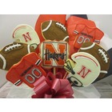 |  |  | 706. Sugar Shack Nebraska cookie bouquet
 |  |  |  | Donated by: The Sugar Shack
 |  |  |  | Enjoy this custom made cookie bouquet from Siouxland's own Sugar Shack. Perfect for the Nebraska Fan in your life!
 |  |  |  |  | Starting Bid: | $40 |  | Value: |  | $50
 | 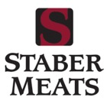 |  |  | 707. Tailgating Package
 |  |  |  | Donated by: Staber Meats
 |  |  |  | Staber Meats has put together a fabulous tailgating package with 10 bs of hamburger and 10lbs of hotdog!
 |  |  |  |  | Starting Bid: | $40 |  | Value: |  | $50
 | 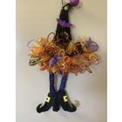 |  |  | 708. Vibrant Witch's Hat Doorhanger
 |  |  |  | Just in time for Halloween this gorgeous hand crafted Witch's Hat doorhanger will bring the right amount of seasonal flair to your front porch!
 |  |  |  |  | Starting Bid: | $25 |  | Value: |  | $40
 | KSCJ
 | 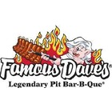 |  |  | 709. Famous Dave's $30 Gift Card (X2)
 |  |  |  | Donated by: Famous Dave's
 |  |  |  | Grab a seat it's BBQ Time! Enjoy Famous Dave's authentic, pit-smoked BBBQ, made-from-scratch sides and handcrafted dessert either in the restaurant or for carry out!
 |  |  |  |  | Starting Bid: | $20 |  | Value: |  | $30
 | 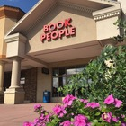 |  |  | 710. Book People
 |  |  |  | $25 Gift Card to Book People
 |  |  |  |  | Starting Bid: | $20 |  | Value: |  | $25
 | 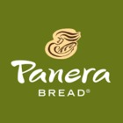 |  |  | 711. $25 Panera Gift Card (X2)
 |  |  |  | Panera Bread believes in raising, serving and eating food that is good and good for you. Enjoy this $25 gift certificate
 |  |  |  |  | Starting Bid: | $15 |  | Value: |  | $25
 |  |  |  | 712. Born Saucy - $25 Gift Cards for Taco Bell
(5) $5 Gift Cards for Taco Bell.
Taco Bell® has all of your favorite Mexican inspired foods. From classic tacos to burritos to our epic specialties and combos, there’s something for everyone at Taco Bell® .
 |  |  |  |  | Starting Bid: | $20 |  | Value: |  | $25
 | KSCJ
 | 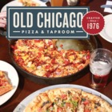 |  |  | 713. $25 Old Chicago Pizza & Taproom Gift Certificate (X4)
 |  |  |  | Donated by: Old Chicago
 |  |  |  | Enjoy Craft Food as Great as their beer! What goes perfectly with our impeccable craft brew selection? Our incredible menu of taproom fare, pizzas, burgers and plates that'll satisfy any craving. What began as a hangout spot for a few friends in Boulder, CO and some great Chicago-style pizza, has grown into an innovative kitchen of fresh, handmade fare.
 |  |  |  |  | Starting Bid: | $20 |  | Value: |  | $25
 | 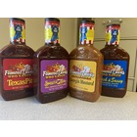 |  |  | 714. Enjoy this set of 4 Famous Dave's BBQ Sauces (X2)
 |  |  |  | Donated by: Famous Dave's
 |  |  |  | Texas Pit, Sweet & Zesty, Georgia Mustard, Rich & Sassy
 |  |  |  |  | Starting Bid: | $7 |  | Value: |  | $12

